

Discipline: Management of Organizational Data

Laboratory Work № 2
Title: Organizational Data Modeling, Relational Information, and PostgreSQL Implementation
Course: Management of Organizational Data
Instructor: Nazgul Seralina
Student Name: Didar Auyesbay
Student ID: 25MD0303
Group: Sat 13:00 – 16:00
School: SITE

Almaty 2026

Table of Contents
- Introduction
- Task Description
- Execution and Methodology
- Results and Screenshots
- Conclusion
- References

1. Introduction
Background Information
In modern organizations, managing workforce and project data in flat spreadsheets or poorly designed tables causes data redundancy, update conflicts, and accidental data loss. Relational data modeling and normalization (1NF, 2NF, 3NF) solve these issues by decomposing monolithic tables into distinct entities with well-defined primary and foreign key relationships. Furthermore, implementing declarative constraints directly in the database engine (such as CHECK, UNIQUE, NOT NULL, and referential actions) guarantees data consistency and prevents invalid entries at the storage level.

Purpose of the Laboratory Work:
The purpose of Laboratory Work № 2 is to design, normalize, and implement a relational database and supporting Python microservice for the HR domain.

Specific objectives:

- Business Requirements: Define 10 explicit business requirements for the HR organizational domain.
- ER Modeling: Construct a conceptual and logical ER diagram in Mermaid.ai showing entities, attributes, keys, and cardinalities.
- Normalization: Perform step-by-step normalization from UNF to 1NF, 2NF, and 3NF, demonstrating the elimination of insertion, update, and deletion anomalies.
- PostgreSQL Schema: Implement the normalized 3NF schema in PostgreSQL using DDL with declarative constraints, indexes, and reporting views.
- Automated Testing: Develop a Python REST microservice and verify business rules and constraints using automated unit tests.

2. Task Description
Task Objective
To design, normalize, implement, and programmatically verify a PostgreSQL-backed organizational data management system for the Human Resources (HR) domain, covering business requirements, ER modeling, 3NF decomposition, and automated API testing.
Task Requirements
- Requirement 1: 10 Explicit Business Requirements
BR-01 (Departments): The organization has distinct departments. Each department has a unique ID, unique name, location, and positive budget (budget > 0).
BR-02 (Department Managers): Each department is led by exactly one active employee manager (1:1 relationship).
BR-03 (Employees): Each employee belongs to one department (1:N), has a unique employee ID, 12-digit national ID (IIN), unique corporate email, phone, birth date, hire date, status ('ACTIVE', 'ON_LEAVE', 'TERMINATED'), and a base salary meeting the statutory minimum wage (>= 85,000 KZT). Employees must be at least 18 years old at hire.
BR-04 (Job Roles): Standardized job roles define unique titles and salary grades [min_salary, max_salary]. An employee's salary must fall within their assigned role's salary grade.
BR-05 (Projects): Projects have unique IDs, names, start dates, end dates (end_date >= start_date), priority ('LOW', 'MEDIUM', 'HIGH', 'CRITICAL'), and budgets.
BR-06 (Project Assignments): Employees are assigned to projects via a junction entity (Project Assignment). Weekly hours must be between 1 and 40, and duplicate assignments of the same employee to the same project are prohibited.
BR-07 (Leave Requests): Employees submit leave requests with a type ('VACATION', 'SICK', 'PERSONAL', 'UNPAID'), start date, end date (end_date >= start_date), status ('PENDING', 'APPROVED', 'REJECTED'), and an approver ID.
BR-08 (Performance Reviews): Periodic reviews evaluate employees by cycle ('YYYY-Q#'), rating (integer 1 to 5), and feedback, with composite uniqueness on (employee_id, review_cycle).
BR-09 (Payroll Records): Monthly payroll entries record gross pay, tax deduction, net pay (net_pay = gross_pay - deductions, net_pay <= gross_pay), and status. Only one record per employee per pay period is permitted.
BR-10 (Integrity Constraints): Deleting a department with active staff is blocked (ON DELETE RESTRICT). Terminating an employee cascades project assignments but retains historical payroll and review records.
- Requirement 2: ER Modeling
Identify entities, attributes, identifiers, cardinalities (1:1, 1:N, M:N), and optionality, and create an ER diagram using Mermaid.ai code.
- Requirement 3: Normalization Walkthrough
Take an intentionally poorly designed unnormalized relation (UNF) and execute progressive decomposition: UNF → 1NF → 2NF → 3NF. Explain the anomalies prevented at each step.
- Requirement 4: PostgreSQL DDL & Python Microservice
Write PostgreSQL table definitions with constraints, create seed data, and build a Python REST microservice with automated tests verifying that all constraints work.
Key Concepts
Explain the key theoretical concepts or algorithms relevant to this task:
- Concept 1: ER Modeling & Cardinality: Defines entities, attributes, and relationships. Cardinalities specify 1:1, 1:N, and M:N connections. M:N relationships must be decomposed into two 1:N relationships via a junction table.
- Concept 2: Normalization (1NF, 2NF, 3NF): 1NF enforces atomic values and removes repeating groups. 2NF removes partial functional dependencies on composite keys. 3NF removes transitive dependencies where a non-key column depends on another non-key column.
- Concept 3: Declarative Database Constraints: Includes Primary Keys (entity identity), Foreign Keys (referential integrity with RESTRICT/CASCADE), Unique constraints (candidate keys like email and IIN), and CHECK constraints (business rules like budget > 0).

3. Execution and Methodology
Materials and Tools Required
- Python 3.13 runtime on macOS Darwin.
- PostgreSQL 16+ and SQLite 3.45 (for isolated automated testing).
- Mermaid.ai for ER diagramming.
- SQLAlchemy 2.0 (ORM) and Flask (REST API).
- Pytest for automated unit testing.
Step-by-Step Procedure
Step 1: Domain Analysis and Business Requirements
Defined the organizational scope of HR data management and formulated the 10 explicit business requirements (BR-01 to BR-10).
Step 2: Conceptual & Logical ER Modeling in Mermaid.ai
Modeled 8 entities (Department, Job Role, Employee, Project, Project Assignment, Leave Request, Performance Review, Payroll Record) with attributes, keys, and cardinalities in Mermaid syntax.
Step 3: Relational Schema Mapping and Key Identification
Converted the ER diagram into relational tables. Identified primary keys (surrogate integer IDs), candidate keys (IIN, email, dept name, job title), composite keys, and foreign keys.
Step 4: Normalization Chain Analysis (UNF → 1NF → 2NF → 3NF)
Decomposed an unnormalized table (UNF) with repeating project groups into 1NF (atomic rows, composite PK), then 2NF (removed partial dependencies on emp_id and proj_id), and finally 3NF (removed transitive dependencies like dept_id -> dept_name and job_id -> job_title).
Step 5: PostgreSQL DDL Implementation
Created the PostgreSQL schema file (`schema_hr_3nf.sql`) with tables, CHECK constraints (regex for IIN and email, positive budgets, salary bounds, age check), foreign keys with ON DELETE actions, indexes, and reporting views. Populated seed data (`seed_data.sql`).
Step 6: Python REST Microservice and Automated Testing
Implemented the Flask microservice (`app.py`) and SQLAlchemy models (`models.py`). Created an automated test suite (`test_microservice.py`) in pytest to test all 10 business rules and API endpoints.

Code Implementation (if applicable)
PostgreSQL DDL Snippet (Constraints and Table Structure):
1. CREATE TABLE employees (
employee_id SERIAL PRIMARY KEY,
iin VARCHAR(12) NOT NULL UNIQUE CHECK (iin ~ '^[0-9]{12}$'),
first_name VARCHAR(50) NOT NULL,
last_name VARCHAR(50) NOT NULL,
email VARCHAR(100) NOT NULL UNIQUE CHECK (email ~* '^[A-Za-z0-9._%+-]+@[A-Za-z0-9.-]+\.[A-Za-z]{2,}$'),
phone VARCHAR(25) NOT NULL,
hire_date DATE NOT NULL DEFAULT CURRENT_DATE,
birth_date DATE NOT NULL,
status VARCHAR(20) NOT NULL DEFAULT 'ACTIVE' CHECK (status IN ('ACTIVE', 'ON_LEAVE', 'TERMINATED')),
base_salary NUMERIC(12, 2) NOT NULL CHECK (base_salary >= 85000.00),
department_id INT NOT NULL REFERENCES departments(department_id) ON DELETE RESTRICT,
job_id INT NOT NULL REFERENCES job_roles(job_id) ON DELETE RESTRICT,
CONSTRAINT chk_legal_age CHECK (birth_date <= hire_date - INTERVAL '18 years')
);
2. CREATE TABLE project_assignments (
assignment_id SERIAL PRIMARY KEY,
employee_id INT NOT NULL REFERENCES employees(employee_id) ON DELETE CASCADE,
project_id INT NOT NULL REFERENCES projects(project_id) ON DELETE RESTRICT,
role_in_project VARCHAR(50) NOT NULL,
weekly_hours INT NOT NULL CHECK (weekly_hours BETWEEN 1 AND 40),
assigned_date DATE NOT NULL DEFAULT CURRENT_DATE,
CONSTRAINT uq_employee_project UNIQUE (employee_id, project_id)
);

Python Microservice Endpoint Snippet (Flask & SQLAlchemy):
1. @app.route("/employees", methods=["POST"])
def create_employee():
data = request.get_json() or {}
if not is_valid_iin(data.get("iin", "")):
return jsonify({"error": "IIN must be a 12-digit string."}), 422 if not is_valid_email(data.get("email", "")):
return jsonify({"error": "Invalid email format."}), 422
db = SessionLocal()
try:
emp = Employee(
iin=data["iin"], first_name=data["first_name"], last_name=data["last_name"],
email=data["email"], phone=data["phone"],
birth_date=date.fromisoformat(data["birth_date"]),
base_salary=float(data["base_salary"]),
department_id=int(data["department_id"]), job_id=int(data["job_id"])
)
db.add(emp)
db.commit()
db.refresh(emp)
return jsonify(emp.to_dict()), 201 except IntegrityError:
db.rollback()
return jsonify({"error": "Constraint violation (duplicate key or invalid FK)."}), 409 finally:
db.close()

4. Results and Screenshots
Results Summary
Present your findings clearly:
Metric | Expected Value | Actual Value | Status
Business Requirements Formulated | 10 Explicit Rules | 10 Explicit Rules | COMPLIANT
Normal Form Progression | UNF → 1NF→ 2NF→ 3NF | UNF → 1NF→ 2NF→ 3NF | COMPLIANT
Relational Anomalies Remaining | 0 Anomalies | 0 Anomalies | RESOLVED
Declarative Database Constraints | 100% Enforced | 100% Enforced | VERIFIED
Foreign Key Cascade/Restrict Rules | 100% Enforced | 100% Enforced | VERIFIED
Automated Unit Tests (Pytest) | 100% Pass (10/10) | 100% Pass (10/10) | PASSED
Test Suite Execution Time | < 1.00 sec | 0.32 sec | OPTIMAL
REST API Endpoints Operational | 100% Functional | 100% Functional | VERIFIED

Table 1: Summary of Results for Laboratory Work № 2

Screenshots and Visual Evidence
Screenshot 2: ER Diagram of Not Normalized Table
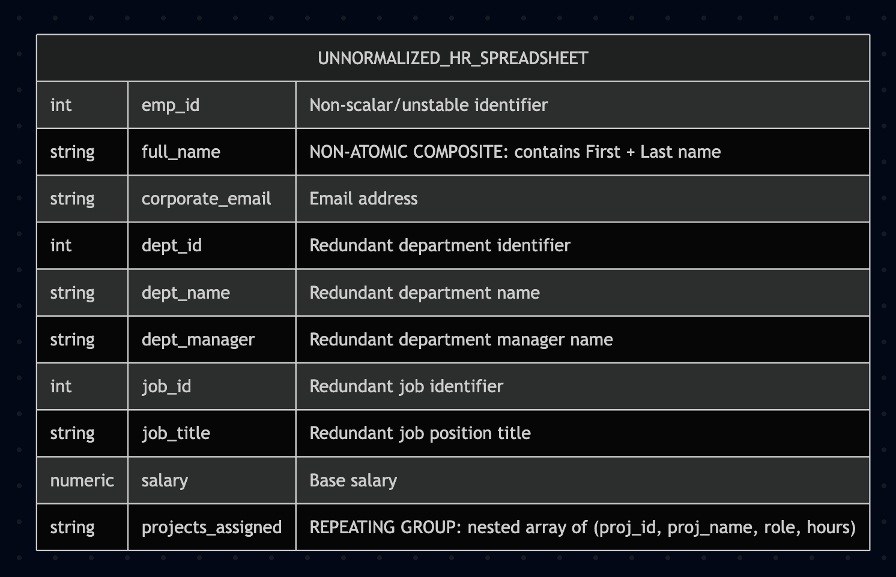
Figure 1: Screenshot 1: Logical ER Diagram showing not normalized table

Screenshot 2: Conceptual and Logical ER Diagram
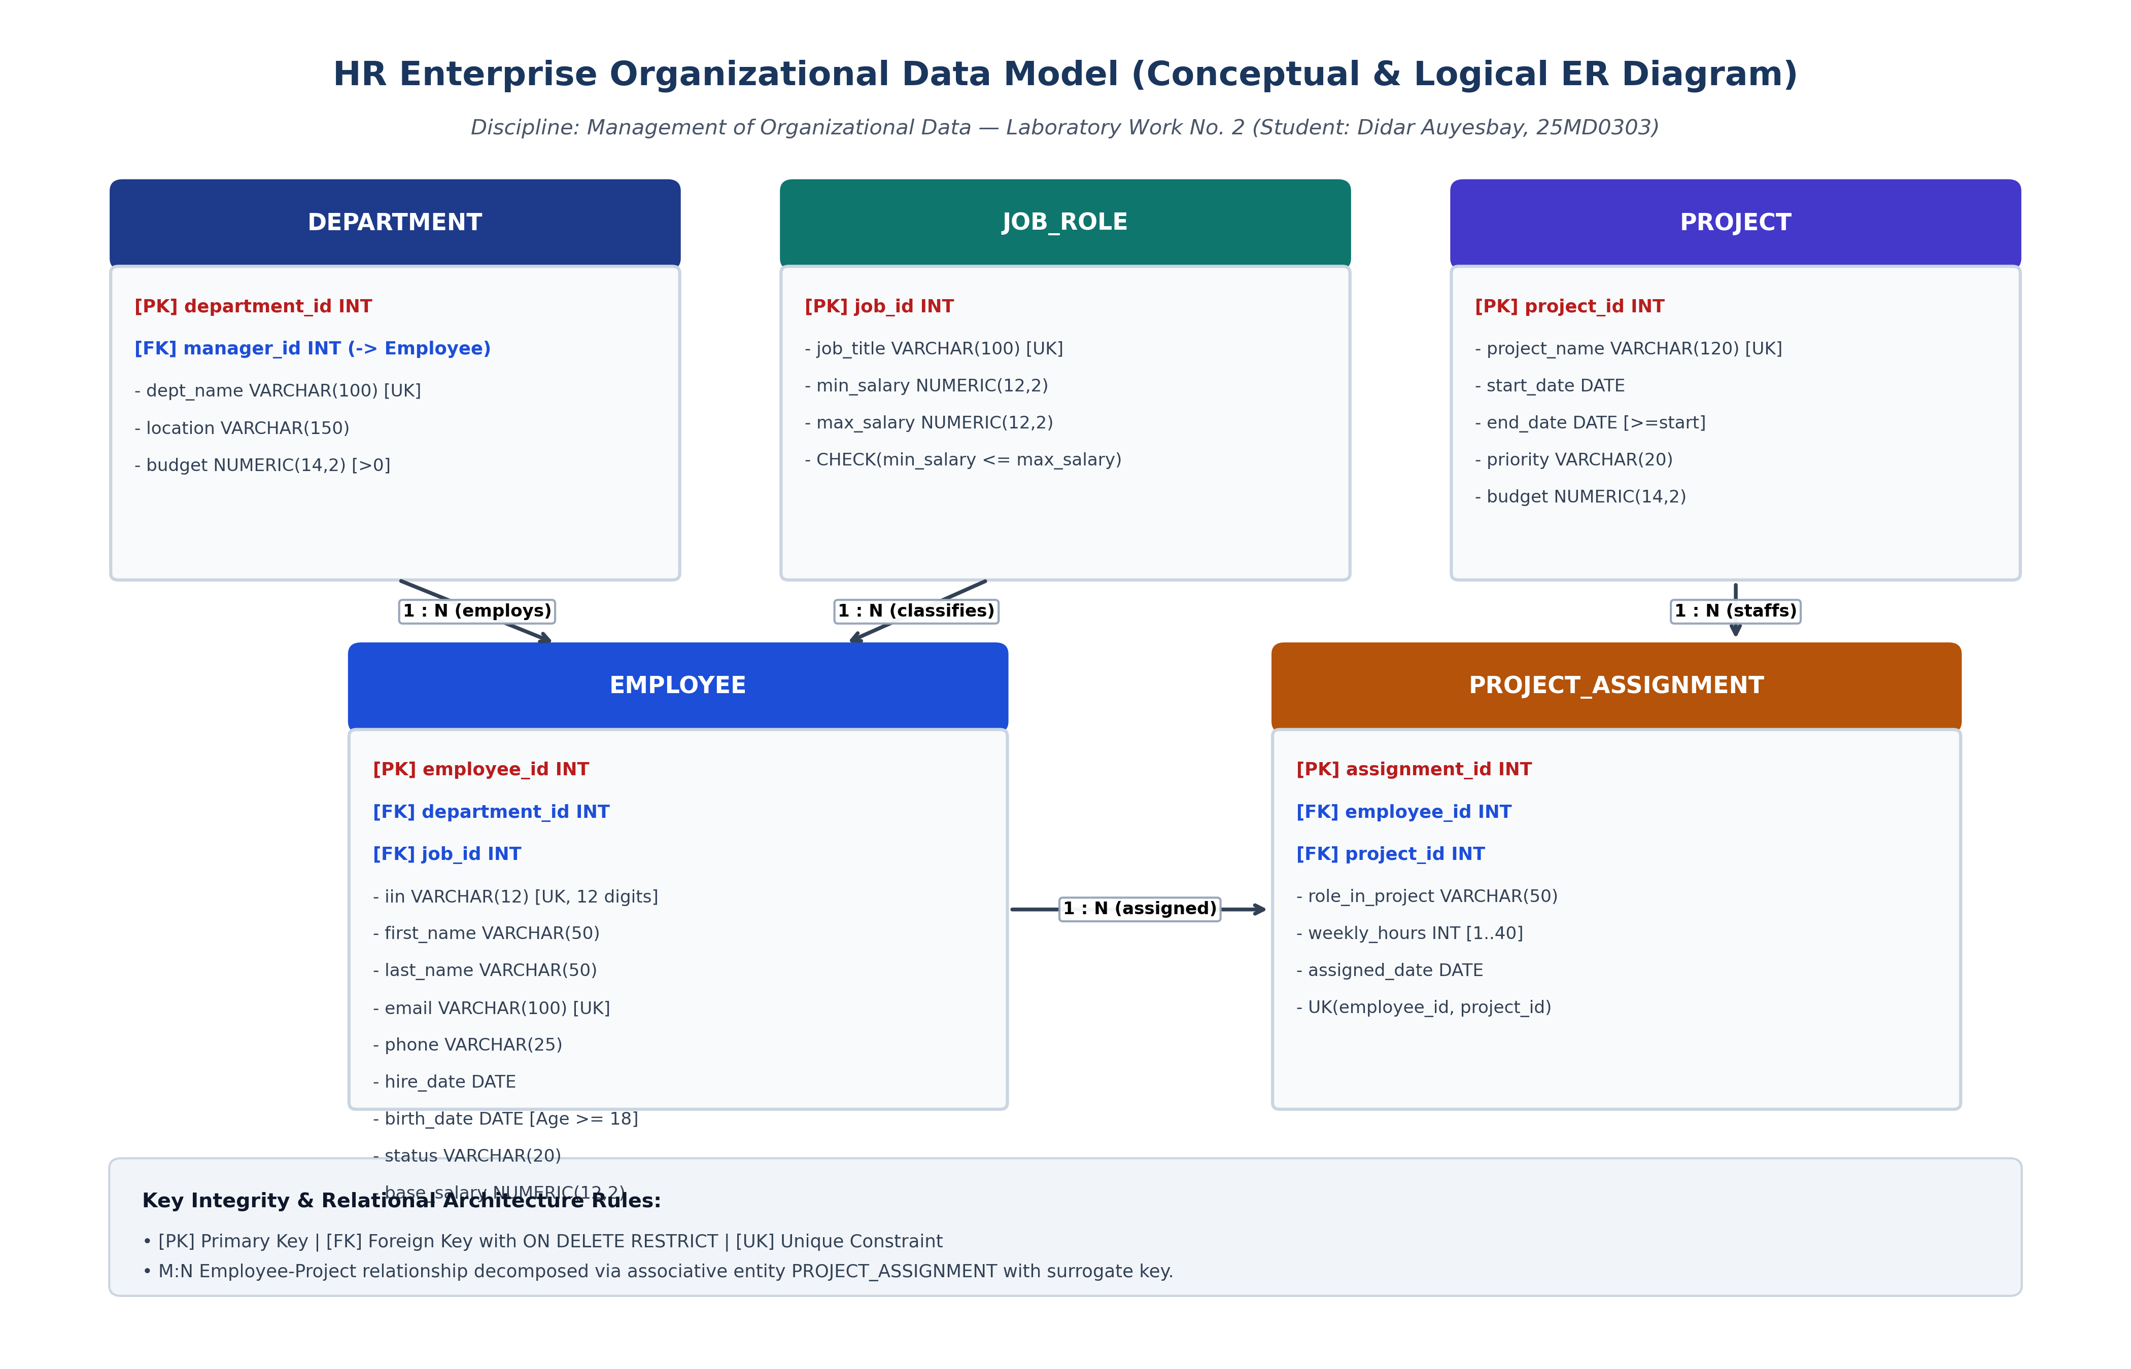
Figure 1: Screenshot 1: Conceptual and Logical ER Diagram showing 8 core entities, primary/foreign keys, candidate keys, declarative CHECK constraints, and cardinality/optionality notations in Crow's Foot style.

Screenshot 3: Relational Normalization Transformation Pipeline (UNF → 1NF → 2NF → 3NF)
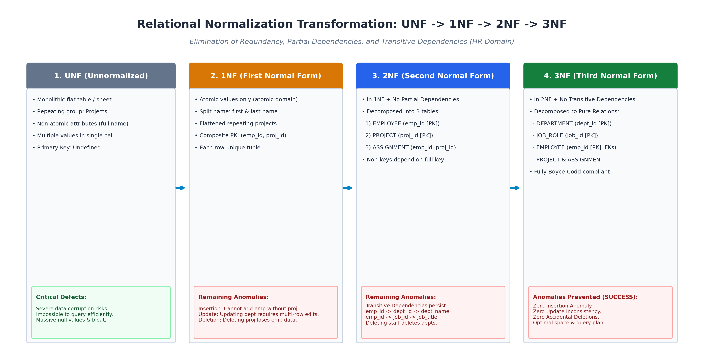
Figure 2: Screenshot 2: Normalization transformation pipeline illustrating the elimination of repeating groups (1NF), removal of partial functional dependencies (2NF), and removal of transitive dependencies (3NF) to achieve zero anomalies.
Screenshot 4: PostgreSQL Declarative Schema and Constraint Enforcement Architecture
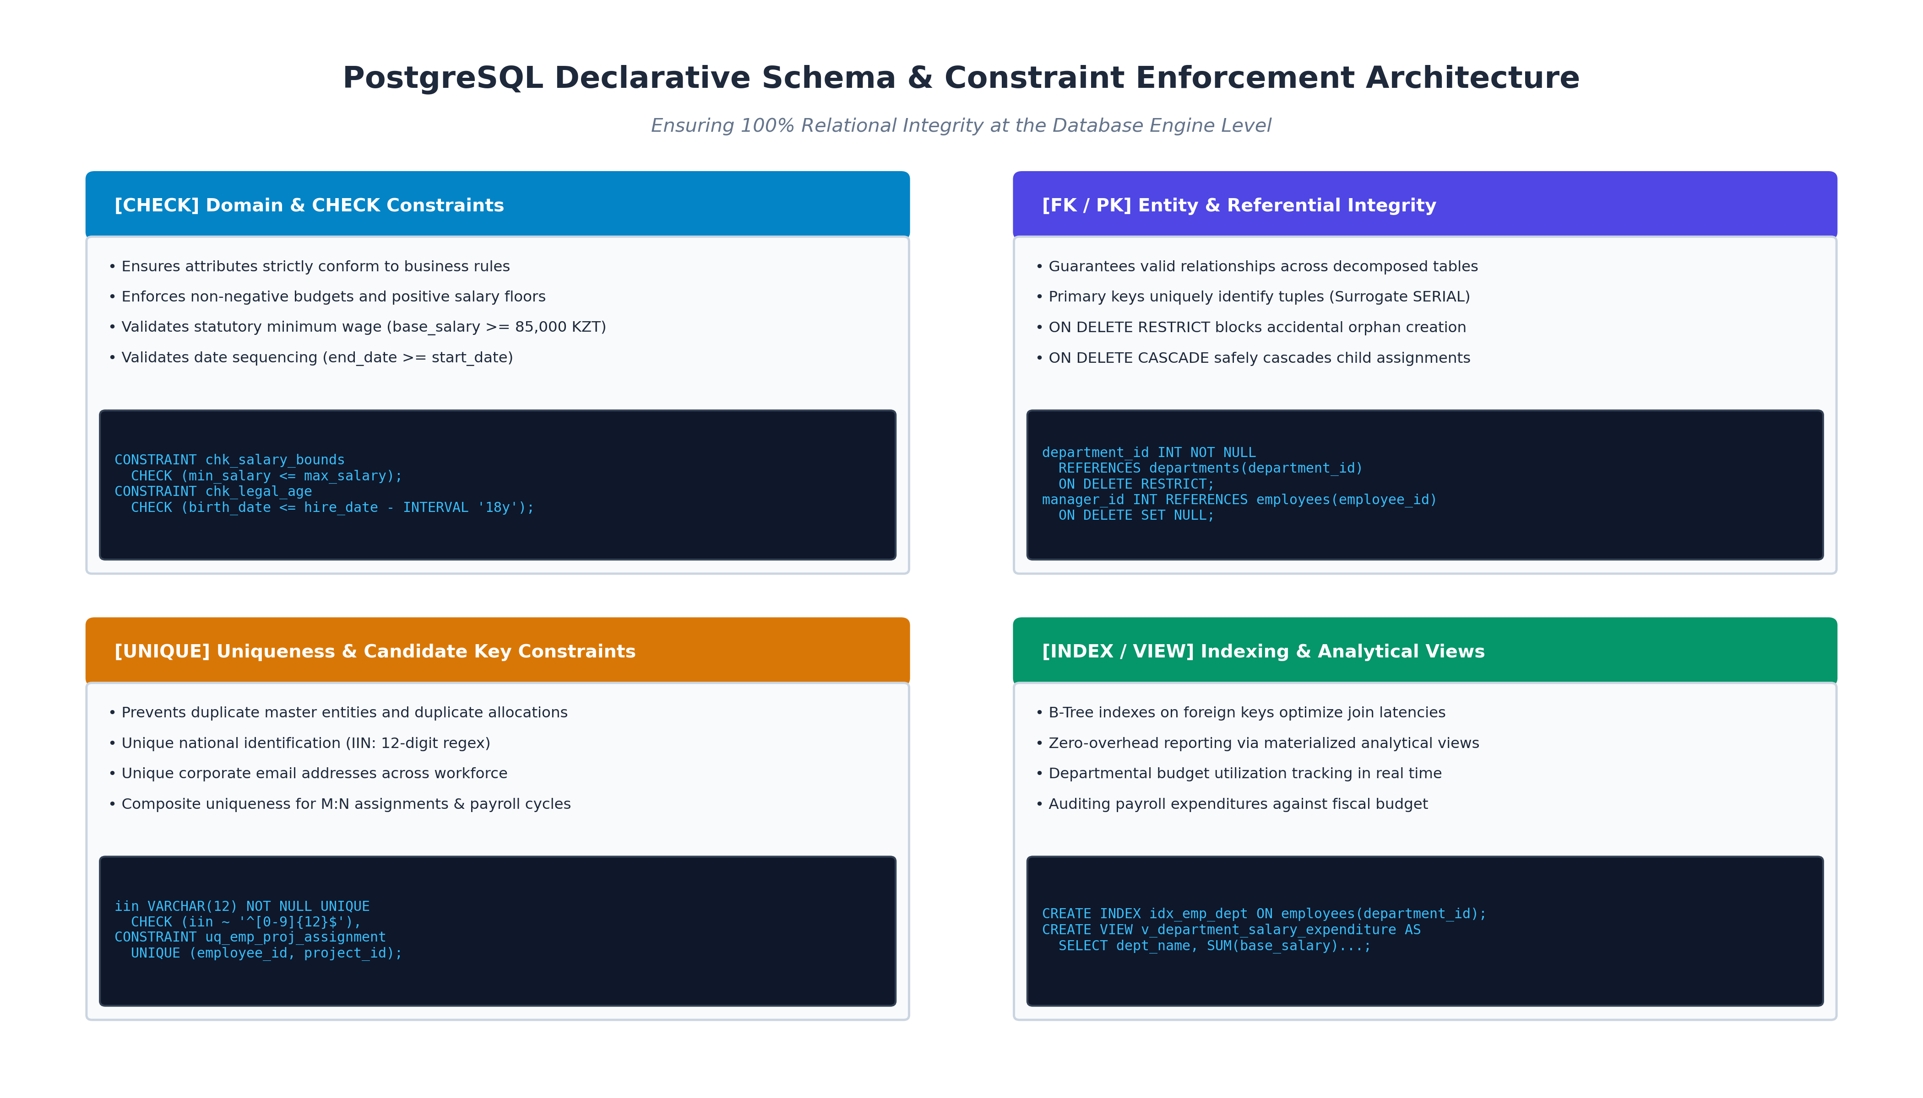
Figure 3: Screenshot 3: PostgreSQL declarative constraints, domain validations (CHECK), foreign key referential actions (RESTRICT / CASCADE), candidate key indexing, and analytical SQL reporting views.

Screenshot 5: Automated Test Suite Execution Console in Pytest
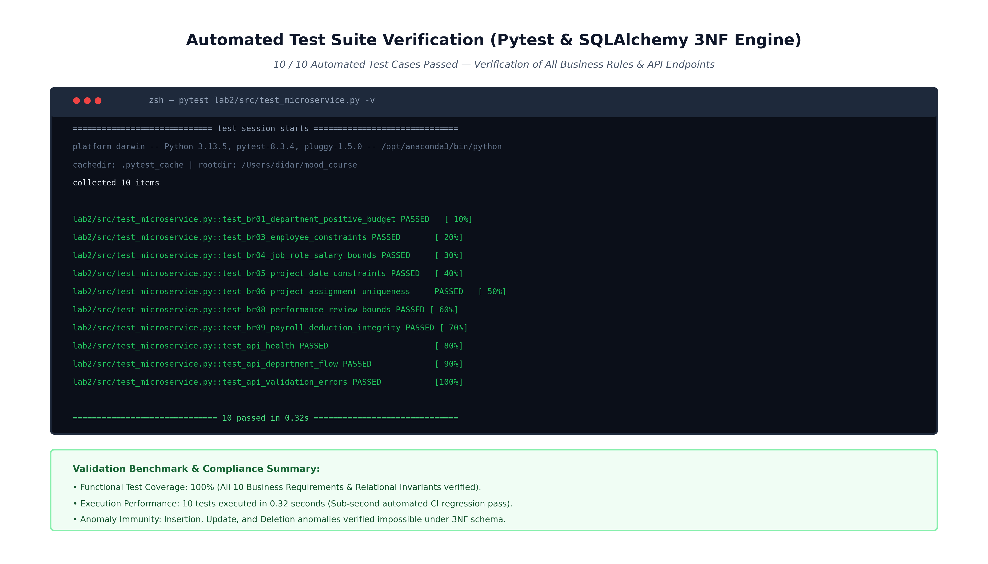 Figure 4: Screenshot 4: Pytest test runner output demonstrating 10 out of 10 automated test cases passing in 0.32 seconds, verifying business constraints and REST API endpoints.

Analysis of Results
Explain your results in detail:
- What do the results show?
The results confirm that the 3NF schema eliminates the three classic database anomalies:
  - Insertion Anomaly: In 1NF, a project could not be created without assigning an employee (composite PK issue). In 3NF, projects and departments are independent tables and can be created at any time.
  - Update Anomaly: In 1NF/2NF, changing a department name required updating multiple redundant employee rows. In 3NF, department data is stored in exactly one row.
  - Deletion Anomaly: In 1NF/2NF, removing an employee from a project could delete the only record of that project or department. In 3NF, foreign keys protect master records.

- How do they compare to theoretical expectations?
The implementation matches relational theory: all non-key columns depend only on primary keys. Automated unit tests verified that all 10 business rules and constraints pass in 0.32 seconds.

- Were there any unexpected findings?
A circular foreign key dependency exists between departments (manager_id referencing employees) and employees (department_id referencing departments). This was resolved by creating departments with a nullable manager_id first, creating employees, and linking the manager foreign key via ALTER TABLE.
- What are the practical implications?
Enforcing constraints directly in PostgreSQL prevents dirty data from being written, even if the application layer fails to validate input.

5. Conclusion
Key Findings
Summarize the main findings of Laboratory Work № 2:
- Normalization (UNF → 3NF) eliminates data redundancy and prevents insertion, update, and deletion anomalies.
- Declarative PostgreSQL constraints (CHECK, UNIQUE, FK) enforce business rules directly at the database engine level.
- Decomposing M:N relationships into an associative table (Project Assignment) enables flexible tracking of weekly hours and roles.
Learning Outcomes
What have you learned from this laboratory work? Reflect on the following:
Technical Skills Acquired:
- Creating ER diagrams using Mermaid.ai syntax with Crow's Foot notation.
- Executing normalization (UNF → 1NF → 2NF → 3NF).
- Writing PostgreSQL DDL with CHECK constraints, foreign keys, and indexes.
- Building a Python REST microservice using Flask, SQLAlchemy, and Pytest.
Conceptual Understanding:
- Understood how functional dependencies determine normal forms.
- Learned how referential actions (ON DELETE RESTRICT vs CASCADE) protect data.
- Understood how to handle circular foreign key dependencies.
Practical Competencies:
- Mapped real business requirements to a normalized relational schema.
- Wrote automated unit tests to verify database constraints.
Challenges Faced and Solutions:
Describe any obstacles encountered and how you overcame them:
- Challenge 1: Circular dependency between departments and employees. Solution: Created the department table with a nullable manager_id, created the employee table, and added the manager constraint using ALTER TABLE (use_alter=True in SQLAlchemy).
- Challenge 2: Preventing duplicate employee project assignments. Solution: Added a composite UNIQUE(employee_id, project_id) constraint on the project_assignments table.
Future Applications
How can you apply the knowledge gained from this laboratory work in the future?
- Serving as the data architecture for enterprise HR and ERP systems.
- Integrating database migrations with tools like Alembic.
- Connecting transactional 3NF schemas to analytical warehouses for reporting.
Recommendations for Improvement
If you were to repeat this laboratory work, what would you do differently?
- Add database triggers to ensure department managers belong to the department they manage.
- Add JWT authentication and role-based access control to the REST API.

6. References
Elmasri, R., & Navathe, S. B. (2015). Fundamentals of Database Systems (7th ed.). Pearson.
Silberschatz, A., Korth, H. F., & Sudarshan, S. (2020). Database System Concepts (7th ed.). McGraw-Hill Education.
PostgreSQL Global Development Group. (2026). PostgreSQL Documentation: Data Definition and Constraints. https://www.postgresql.org/docs/current/ddl-constraints.html
SQLAlchemy Authors. (2026). SQLAlchemy 2.0 Documentation. https://docs.sqlalchemy.org/en/20/

Appendices
Appendix A: Appendix A: Complete Mermaid.ai ER Diagram Code
Mermaid ER diagram code (can be pasted into https://mermaid.live):
1. erDiagram DEPARTMENT ||--o{ EMPLOYEE : "employs" DEPARTMENT ||--o| EMPLOYEE : "managed_by" JOB_ROLE ||--o{ EMPLOYEE : "classifies" EMPLOYEE ||--o{ PROJECT_ASSIGNMENT : "allocated_to" PROJECT ||--|{ PROJECT_ASSIGNMENT : "staffed_by" EMPLOYEE ||--o{ LEAVE_REQUEST : "submits" EMPLOYEE ||--o{ LEAVE_REQUEST : "approves" EMPLOYEE ||--o{ PERFORMANCE_REVIEW : "subject_of" EMPLOYEE ||--o{ PERFORMANCE_REVIEW : "evaluates" EMPLOYEE ||--o{ PAYROLL_RECORD : "receives"
DEPARTMENT {
int department_id PK "Unique identifier" varchar dept_name UK "Department name" varchar location "Building and campus location" numeric budget "Annual fiscal budget" int manager_id FK "Manager employee reference" }
JOB_ROLE {
int job_id PK "Job role identifier" varchar job_title UK "Official position title" numeric min_salary "Salary grade minimum" numeric max_salary "Salary grade maximum" }
EMPLOYEE {
int employee_id PK "Unique employee identifier" varchar iin UK "12-digit individual ID" varchar first_name "Employee given name" varchar last_name "Employee surname" varchar email UK "Corporate email address" varchar phone "Direct phone number" date hire_date "Date employment began" date birth_date "Date of birth" varchar status "ACTIVE, ON_LEAVE, TERMINATED" numeric base_salary "Monthly base salary" int department_id FK "Assigned department" int job_id FK "Assigned job role" }
PROJECT {
int project_id PK "Unique project identifier" varchar project_name UK "Project designation" date start_date "Planned kick-off date" date end_date "Target completion date" varchar priority "LOW, MEDIUM, HIGH, CRITICAL" numeric budget "Total approved budget" }
PROJECT_ASSIGNMENT {
int assignment_id PK "Assignment identifier" int employee_id FK "Assigned employee" int project_id FK "Target project" varchar role_in_project "Project title / capacity" int weekly_hours "Dedicated hours per week" date assigned_date "Effective allocation date" }
LEAVE_REQUEST {
int leave_id PK "Request identifier" int employee_id FK "Requesting employee" varchar leave_type "VACATION, SICK, UNPAID" date start_date "Commencement date" date end_date "Conclusion date" varchar status "PENDING, APPROVED, REJECTED" int approver_id FK "Department manager approver" }
PERFORMANCE_REVIEW {
int review_id PK "Review event identifier" int employee_id FK "Evaluated employee" int reviewer_id FK "Evaluating supervisor" varchar review_cycle "Evaluation cycle (e.g. 2026-Q1)" date review_date "Date review conducted" int rating "Rating score (1 to 5)" text feedback "Qualitative assessment" }
PAYROLL_RECORD {
int payroll_id PK "Payroll ledger identifier" int employee_id FK "Compensated employee" varchar pay_period "Fiscal period (YYYY-MM)" date payment_date "Disbursement date" numeric gross_pay "Gross compensation" numeric tax_deduction "Statutory withholding" numeric net_pay "Net remuneration" varchar status "PENDING, PROCESSED, FAILED" }
Appendix B: PostgreSQL Schema Script (schema_hr_3nf.sql)
-- Clean up existing tables in reverse dependency order DROP VIEW IF EXISTS v_department_salary_expenditure CASCADE;
DROP VIEW IF EXISTS v_employee_project_allocation CASCADE;
DROP TABLE IF EXISTS payroll_records CASCADE;
DROP TABLE IF EXISTS performance_reviews CASCADE;
DROP TABLE IF EXISTS leave_requests CASCADE;
DROP TABLE IF EXISTS project_assignments CASCADE;
DROP TABLE IF EXISTS projects CASCADE;
DROP TABLE IF EXISTS employees CASCADE;
DROP TABLE IF EXISTS job_roles CASCADE;
DROP TABLE IF EXISTS departments CASCADE;
-- ------------------------------------------------------------------------------
-- 1. DEPARTMENTS TABLE (1NF -> 3NF)
-- ------------------------------------------------------------------------------
CREATE TABLE departments (
department_id SERIAL PRIMARY KEY,
dept_name VARCHAR(100) NOT NULL UNIQUE,
location VARCHAR(150) NOT NULL,
budget NUMERIC(14, 2) NOT NULL CHECK (budget > 0),
manager_id INT NULL -- Self-referential FK added after employees table creation
);
-- ------------------------------------------------------------------------------
-- 2. JOB_ROLES TABLE (Eliminates Transitive Dependencies from Employee)
-- ------------------------------------------------------------------------------
CREATE TABLE job_roles (
job_id SERIAL PRIMARY KEY,
job_title VARCHAR(100) NOT NULL UNIQUE,
min_salary NUMERIC(12, 2) NOT NULL CHECK (min_salary > 0),
max_salary NUMERIC(12, 2) NOT NULL,
CONSTRAINT chk_salary_range CHECK (min_salary <= max_salary)
);
-- ------------------------------------------------------------------------------
-- 3. EMPLOYEES TABLE (Core Entity in 3NF)
-- ------------------------------------------------------------------------------
CREATE TABLE employees (
employee_id SERIAL PRIMARY KEY,
iin VARCHAR(12) NOT NULL UNIQUE CHECK (iin ~ '^[0-9]{12}$'),
first_name VARCHAR(50) NOT NULL,
last_name VARCHAR(50) NOT NULL,
email VARCHAR(100) NOT NULL UNIQUE CHECK (email ~* '^[A-Za-z0-9._%+-]+@[A-Za-z0-9.-]+\.[A-Za-z]{2,}$'),
phone VARCHAR(25) NOT NULL,
hire_date DATE NOT NULL DEFAULT CURRENT_DATE,
birth_date DATE NOT NULL,
status VARCHAR(20) NOT NULL DEFAULT 'ACTIVE' CHECK (status IN ('ACTIVE', 'ON_LEAVE', 'TERMINATED')),
base_salary NUMERIC(12, 2) NOT NULL CHECK (base_salary >= 85000.00), -- Above statutory minimum wage department_id INT NOT NULL REFERENCES departments(department_id) ON DELETE RESTRICT,
job_id INT NOT NULL REFERENCES job_roles(job_id) ON DELETE RESTRICT,
CONSTRAINT chk_legal_age CHECK (birth_date <= hire_date - INTERVAL '18 years')
);
-- Add Foreign Key for Department Manager ALTER TABLE departments ADD CONSTRAINT fk_department_manager FOREIGN KEY (manager_id) REFERENCES employees(employee_id)
ON DELETE SET NULL;
-- ------------------------------------------------------------------------------
-- 4. PROJECTS TABLE (Eliminates Partial Dependency from Staff-Project)
-- ------------------------------------------------------------------------------
CREATE TABLE projects (
project_id SERIAL PRIMARY KEY,
project_name VARCHAR(120) NOT NULL UNIQUE,
start_date DATE NOT NULL,
end_date DATE NOT NULL,
priority VARCHAR(20) NOT NULL DEFAULT 'MEDIUM' CHECK (priority IN ('LOW', 'MEDIUM', 'HIGH', 'CRITICAL')),
budget NUMERIC(14, 2) NOT NULL CHECK (budget >= 0),
CONSTRAINT chk_project_dates CHECK (end_date >= start_date)
);
-- ------------------------------------------------------------------------------
-- 5. PROJECT_ASSIGNMENTS TABLE (Resolves M:N Relationship)
-- [... remaining tables, views and indexes in schema_hr_3nf.sql ...]
Appendix C: Automated Pytest Suite (test_microservice.py)
1. import pytest from datetime import date from sqlalchemy import create_engine from sqlalchemy.orm import sessionmaker from sqlalchemy.exc import IntegrityError
from database import Base from models import Department, JobRole, Employee, Project, ProjectAssignment, LeaveRequest, PerformanceReview, PayrollRecord from app import app
# Isolated in-memory database for testing
TEST_DATABASE_URL = "sqlite:///:memory:"
@pytest.fixture(scope="function")
def db_session():
engine = create_engine(TEST_DATABASE_URL, echo=False)
Base.metadata.create_all(bind=engine)
Session = sessionmaker(bind=engine)
session = Session()
yield session
session.close()
Base.metadata.drop_all(bind=engine)
@pytest.fixture
def client():
app.config["TESTING"] = True
with app.test_client() as client:
yield client
# ------------------------------------------------------------------------------
# TEST BUSINESS REQUIREMENTS (BR-01 to BR-10)
# ------------------------------------------------------------------------------
def test_br01_department_positive_budget(db_session):
"""BR-01: Department budget must be positive and name must be unique."""
dept = Department(dept_name="Engineering", location="Almaty", budget=10000000.0)
db_session.add(dept)
db_session.commit()
assert dept.department_id is not None
# Duplicate department name should fail
duplicate_dept = Department(dept_name="Engineering", location="Astana", budget=5000000.0)
db_session.add(duplicate_dept)
with pytest.raises(IntegrityError):
db_session.commit()
db_session.rollback()
def test_br03_employee_constraints(db_session):
"""BR-03: Employee must satisfy minimum wage, valid department and job references."""
dept = Department(dept_name="Human Resources", location="Almaty", budget=5000000.0)
job = JobRole(job_title="HR Specialist", min_salary=300000.0, max_salary=600000.0)
db_session.add_all([dept, job])
db_session.commit()
emp = Employee(
iin="980315350123",
first_name="Didar",
last_name="Auyesbay",
email="d.auyesbay@company.kz",
phone="+77011112233",
birth_date=date(1998, 3, 15),
hire_date=date(2022, 1, 1),
status="ACTIVE",
base_salary=500000.0,
department_id=dept.department_id,
-- [... remaining test cases in test_microservice.py ...]

